Citizen Grievance & Sentiment Analysis System
SUBMITTED BY UVESH SHAIKH

Week 2 Report: Text Vectorization and Complaint Classification Model

1. Introduction

In Week 2, the focus of the project was to build a machine learning model capable of automatically classifying citizen complaints into different categories. This was achieved by converting textual data into numerical form and applying classification algorithms.

2. Feature Selection

The input feature for the model is the cleaned text data (clean_text), which was prepared in Week 1. The target variable is the Complaint Type, which represents different categories of complaints.

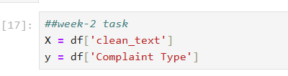

3. Text Vectorization (TF-IDF)

Since machine learning models cannot understand text directly, the text data was converted into numerical format using TF-IDF (Term Frequency-Inverse Document Frequency). This technique assigns importance to words based on their frequency.

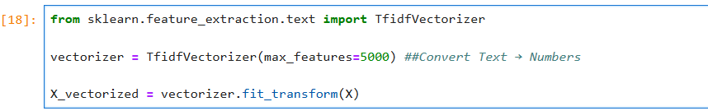

4. Data Splitting
The dataset was divided into training and testing sets to evaluate the model’s performance. 80% of the data was used for training and 20% for testing.
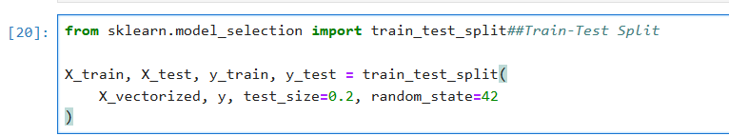

5. Model Training
A Logistic Regression model was used for classification. This algorithm is simple, efficient, and suitable for text classification tasks.

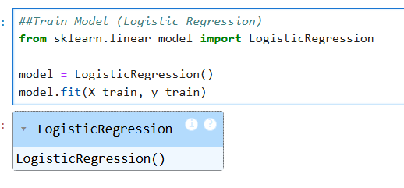

6. Model Evaluation

The model’s performance was evaluated using accuracy score and classification metrics such as precision, recall, and F1-score.

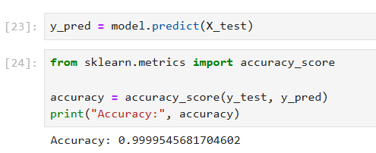

7. Confusion Matrix Visualization

A confusion matrix was generated to visualize the model’s performance by comparing actual and predicted values.

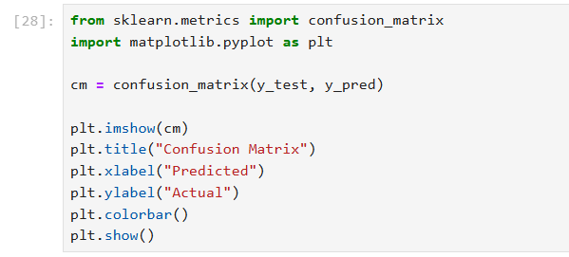

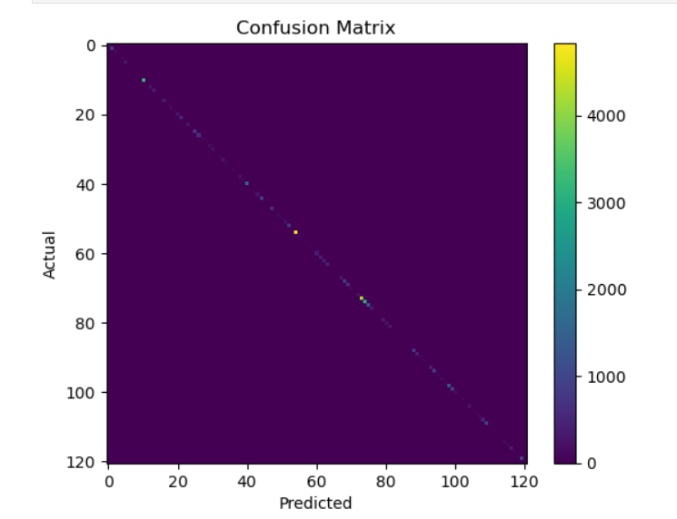

8. Key Insights
- TF-IDF effectively converted text data into numerical features
- Logistic Regression performed well for classification
- The model was able to correctly predict most complaint categories
- Evaluation metrics helped in understanding model performance

9. Conclusion

In Week 2, a machine learning model was successfully developed to classify citizen complaints. Text data was transformed using TF-IDF, and a Logistic Regression model was trained and evaluated. The results demonstrate that machine learning can effectively automate complaint categorization, forming a strong base for further improvements in sentiment analysis and model optimization in the next phase.

